10/100M 8-port Industrial Ethernet POE Switch
Industrial Ethernet POE Switch Series
1/4
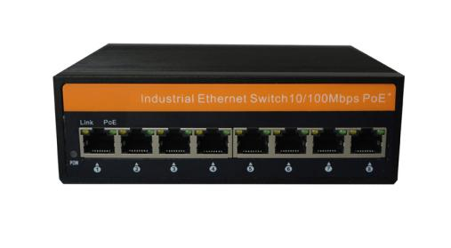
Product Description

8-port 100M Industrial Ethernet POE switch, supporting 8*10Base-T/100Base-TX POE RJ45 ports. The product complies with FCC and CE standards. This series switches have an operating temperature of -40°C to 85°C. They have excellent robustness to adapt to a variety of harsh environments, and can also be conveniently placed in compact control cabinets. The installation characteristics of the guide rails, wide temperature operation and enclosures with IP40 degree of protection and LED indicators make it a plug-and-play industrial-grade device that provides a reliable and convenient solution for the networking of users' Ethernet equipment.

Product Features

- High quality photoelectric integrated modules provide good optical and electrical properties;
- Guaranteed reliable data transmission and long working life;
- Support full-duplex or half-duplex mode with auto-negotiation capability;
- The network port supports automatic cross-recognition;
- Internal storage and forwarding mechanism, support multiple protocols;
- Compliant with carrier-grade operating standards, with an average trouble-free operation of over 300,000 hours;
- Working power supply: DC 48-57V provides reverse connection protection;
- Lightning surge protection (power supply): 5000A (8/20μs);

Industrial Ethernet POE Switch Series
Series

2/4
Technical Specification

Technical Parameters
Product Name | 100M 8-port Industrial Ethernet POE Switch
Product Description | 8-port 100M Industrial Ethernet POE switch,
Network protocol | IEEE802.3 10BASE-T; IEEE802.3i 10Base-T; IEEE802.3u 100Base-TX/FX;  IEEE802.3ab 1000Base-T; IEEE802.3z 1000Base-X; IEEE802.3x;IEEE802.3af; IEEE802.3at
POE Standard | Standard POE : IEEE802.3af/ IEEE802.3at
POE Standard | POE port: 1~8 ports supports POE
POE Standard | Output Power :  Maximum power 15.4W (IEEE 802.3af)  Maximum power 25.5W (IEEE 802.3at)  POE port automatically recognizes af/at
POE Standard | Output voltage : DC48-57V
POE Standard | Power supply mode : 1/2+; 3/6-
RJ45 port | 10/100BaseT (X) automatic detection, full / half duplex MDI / MDI-X adaptive
Twisted pair | 10BASE-T : Cat3, 4, 5 UTP (≤100 meter)  100BASE-TX : Cat5 or later UTP (≤100 meter)  1000BASE-TX : Cat6 or later UTP (≤100 meter)
Switch Properties | Application Level: Layer 2  Total backplane bandwidth: 1Gbps  Overall package forwarding rate: 0.744Mpps  MAC table: 1K  Packet buffer: 512K  Delay time: <3μs  Exchange method: store-forward
Protection level | IP40
LED indicator | Power indicator : PWR  Interface indicator: Electrical port, Optical port (Link/ACT)
Power supply | Input voltage: DC48-57V (dual power redundant backup)  Access terminal: Phoenix terminal  Support dual power redundancy  Support built-in overcurrent 4.0A protection  Support reverse connection protection
Other specifications
Working environment | Operating temperature: -40 ° C ~ + 85 ° C  Storage temperature: -40 ° C ~ + 85 ° C  Relative humidity: 5 ~ 95% (non- condensing)
Industrial Ethernet POE Switch Series  Series  3/4 | EMI: FCC Part 15 Subpart B Class A, EN 55022 Class A.  EMS:  IEC61000-4-2 (ESD): ±8kV (contact), ±15kV (air)  IEC61000-4-3 (RS): 10V/m (80-1000MHz)  IEC61000-4-4 (EFT): Power Port: ±4kV; Data Port: ±2kV  IEC61000-4-5 (Surge): Power Port: ±2kV/DM, ±4kV/CM; Data Port: ±2kV  IEC61000-4-6(CS):3V(10kHz-150kHz);10V(150kHz-80MHz)  IEC61000-4-16 (Common mode conduction): 30V (cont.), 300V (1s)  IEC(EN )61000-4-8  Shock ：IEC 60068-2-27  Freefall ：IEC 60068-2-32  Vibration ：IEC 60068-2-6
Mechanical properties | Shell: metal material  Installation: DIN rail type, wall-mounted installation  Weight: 0.64Kg
MTBF | 300,000 hours
Warranty | 5-years

Installation size (unit: mm)

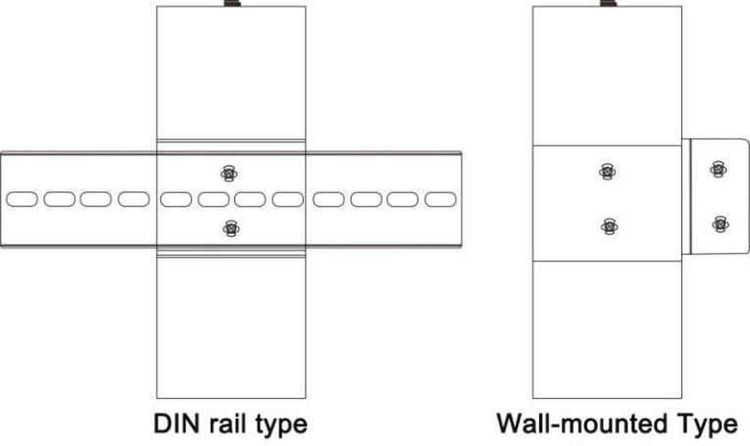
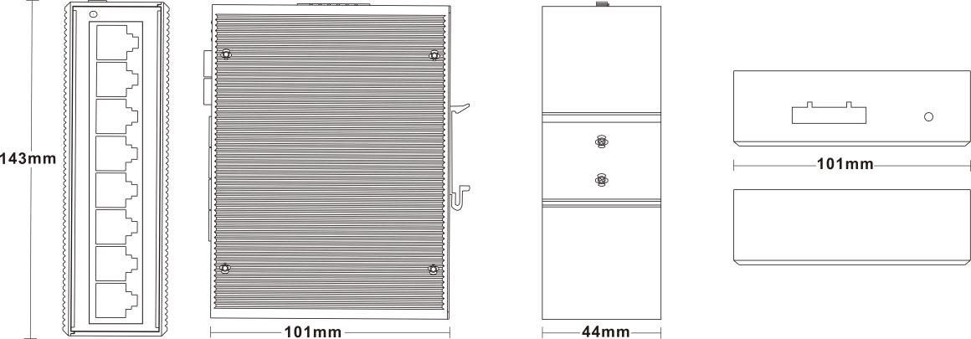
Installation method

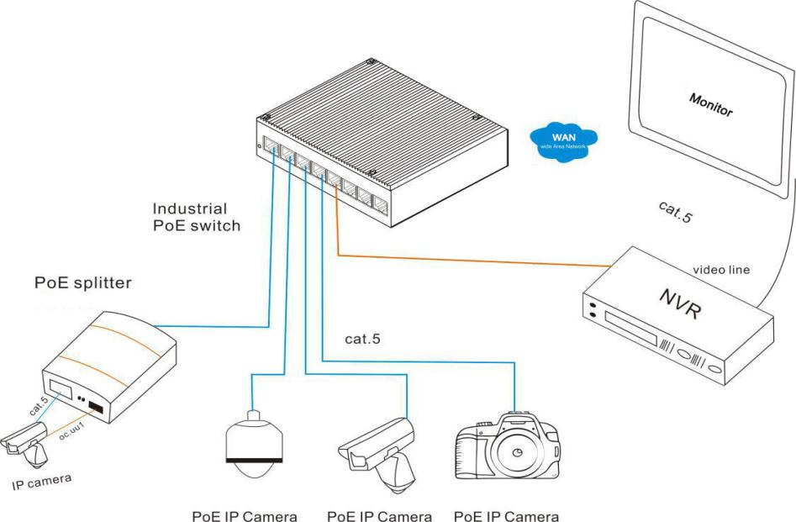
Industrial Ethernet POE Switch Series
Series

4/4
Application

