
Protocol Converter Series

1/3
8E1-10/100Base-T Protocol Converter
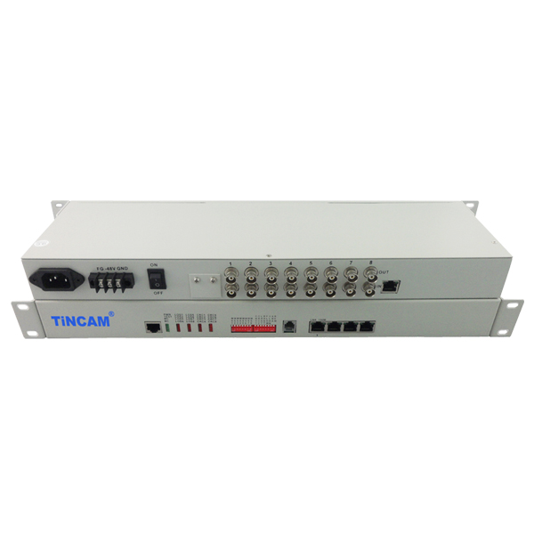
DESCRIPTION

The TBC-CT6008 series protocol converters are developed from the dedicated ASIC developed Ethernet to TDM stream reverse multiplexing equipment, its greatest feature is that from the FE (FX) interface Ethernet data through the packaging process after the formation of The EoPDH signal is mapped to the E1, and the Ethernet data is transmitted to the remote end through the PDH network and the SDH network. In the reverse direction, the EoPDH signal on the unified E1 port is demapped to the Ethernet (FE) port, In order to achieve the use of E1 on the Ethernet data for long-distance transmission or access.This interface converter can send and receive signals E1 channel point-to-point transmission RJ45 interface, E1 channel and Ethernet interconnection. Unlike a typical remote bridge, it supports flexible configuration of 1-8 E1 channels, automatically detects the number of E1s and selects available E1s, and allows for some transmission delay differences between E1 circuits. Single-line rate is 1920Kbit/s, 8-channel bandwidth up to 15360Kbit/s. When using the device at 10/100Mbps full/half duplex mode, can be connected to an Ethernet switch or hub, to fully utilize the existing telecommunications network resources to a large number of E1 circuits extend the transmission distance and the scope of application of Ethernet. It is a good solution for Ethernet broadband access. This product can be used for LAN interconnection, central office interconnection, video on demand, remote monitoring, E1 interface card switch and other fields.
FEATURES

- Realize the transparent transmission of Ethernet data in 1 ~ 8E1 circuit;
- CRC alarm threshold can be set to automatically isolate the line with poor transmission quality, and it is unidirectional to cut off when 2M branch;
- When the error rate in one direction exceeds the threshold, the direction is cut off and the other direction is not affected. That is, the two directions of the Ethernet transmission can be asymmetric.
- To allow multi-E1 has 10ms transmission delay difference. When the difference exceeds the allowable range, the system can automatically stop sending data over the E1 with too much delay. Loopback: E1 local loopback and E1 remote loopback;
- Built-in dynamic Ethernet MAC address list (4096), with local data frame filtering;
- E1 interface with ITU-T G.703, G.704 and G0823; E1 interface module contains a built-in clock recovery circuit and HDB3 codec circuit;
- Equipment supports E1 channel hot swap, and automatically detects the effective E1 channel, the middle will not interrupt the data transfer;
- Support E1 ~ 8E1 flexible configuration, the number of E1 automatically detects the reset and delay and select the available E1 port;
- Support the local system to reset the remote system; with Ethernet monitoring automatic reset function.

Protocol Converter Series

2/3

APPLICATION

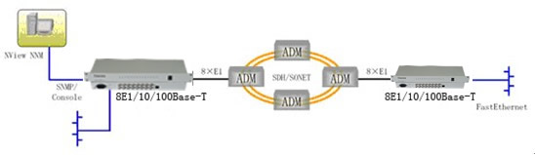

Solution Description: In the point-to-multi point access mode, the 8E1- 10/100Base-T protocol converter can be deployed in the Large customer center room or its corresponding operator's machine room to utilize VLAN functions (port VLAN and 802.1Q VLAN) , Carry on unified planning to VLAN ID of the whole special network, distinguish different kinds of business, save the cost of the customer end exchanger. The user branch nodes can be placed single, multi-E1 protocol converter to complete each branch node access, for each branch users to provide optional 64K ~ 2M or 2M ~ 16M bandwidth data services, completed a large Customers a variety of bandwidth Ethernet access, but also greatly facilitate the installation of equipment and maintenance of the project ,it is very suitable for financial, government, business, prosecutors, tax and other multi-branch node user's private network.

Protocol Converter Series

3/3
Ethernet Interface | Number of interface | 1-RJ45 port
Ethernet Interface | Support frame length | Maximum Ethernet data frame length support 1536Byte
Ethernet Interface | Protocol | Support automatic cross network cable recognition ability;  Support IEEE 802.3x flow control in full duplex mode;  Support Back pressure flow control when half-duplex mode ;  Support 802.3 (Ethernet protocol), 802.3u (Fast Ethernet protocol);  It can transparently transmit IEEE 802.1d Spanning Tree and IEEE 802.1q VLAN packets.
E1 Interface | Transmission mode | Only provide E1 framing mode
E1 Interface | Interface Impedance | 75Ω (unbalance), 120Ω (balance)
E1 Interface | Number of interfaces | Provide 8 E1 interface
E1 Interface | Forwarding Index | Each E1 Ethernet packet forwarding the ultimate rate of 1920Kbps;  8 E1 full load, the ultimate forwarding rate of 1920*8 =15360Kbps;
Features | Network management capabilities | Can support the network management; can manage the local / remote
Features | Network management capabilities | card device can be placed in multi-slot chassis to use, to achieve central office, remote network management
Features | Network management capabilities | desktop without CONSOLE, SNMP interface ;can be controlled by dialing switch, set to Remote devices can realize passive network management
Features | Clock Mode | Two clock modes are provided: master clock (internal clock), slave clock (E1 receive recovery clock),
Features | CRC check | Support CRC4 calibration adaptive
Features | Port loopback | Provides local and remote loopback testing
Features | 窗体顶端  Support mixed insert窗体底端  Support mixed insert | Modular protocol converter can be inserted into 4U chassis, and can be mixed with modular transceiver and optical transceiver products.
Power | Power supply | AC110~240V DC36V~-72V
Power | Power consumption | ＜5W
Physical Dimension | Internal power supply | 216mm*140mm*31mm(Desktop)  430mm*138mm*44mm(Rack-mount)
Working environment | Working temperature | 0°C ~ 45°C
Working environment | Working Humidity | 5%~90% (non condensing)
Working environment | Storage temperature | -25°C ~ 70°C
Working environment | Storage Humidity | 5%~90% (non condensing)
TECHNICAL SPECIFICATIONS

Application 2

