
Protocol Converter Series

1/3
E1-V.35 Protocol Converter
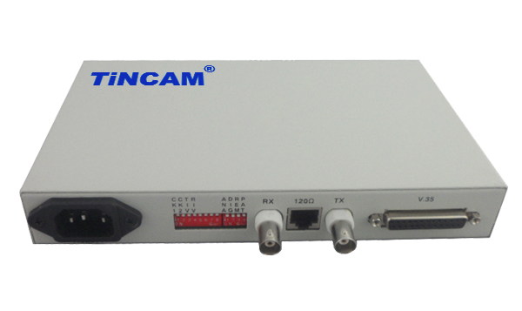

DESCRIPTION

The TBC-CT6001 series E1 to V.35 protocol converter achieves the conversion of G703/E1 and V.35 interface level to meet the requirements of routers and optical transceivers with V.35 interface but without G703 interface to transmit data through E1 optical transceiver or directly through E1 line . The protocol converter takes advantage of the free time slots in E1 to arbitrarily extract time slots from G703/E1 and provides V.35 with a bandwidth of N*64K (N = 1~ 32)for the devices that need to transmit data only at the egress of V.35 Channel, and can be transmitted through optical transceiver and other transmission equipment. This interface converter receives synchronized 2.048Mbps data from E1 and delivers it to routers, DDNs, multiplexers, or other devices to provide secure, seamless communication between devices on different interfaces in the network connection. Widely used in WAN and LAN interconnection, video surveillance and other occasions.

FEATURES

- V.35 interface data can be achieved in the E1 line transparent transmission and sub-timeslot transmission, the bandwidth range of 64Kbps-2048Kbps;
- When framing is used in pairs, the time slot configuration of the remote device can automatically follow the settings of the local device;
- Provide local and remote loopback testing capabilities to facilitate the detection of lines and equipment opening and maintenance;
- Provide the failover function, which can notify the V.35 interface of the line side fault and judge the E1 line fault from the router;
- Built-in error code test unit, loop diagnosis can be used in conjunction with the loop test;
APPLICATION

The V.35 to E1 protocol converter is a communication device that uses the E1 line to transmit V.35 interface services over long distances and provides a solution for remote connection from the router to the router. The device provides one V.35 interface and one E1 interface, supporting transparent transmission of E1 and framing transmission of N* 64Kbps (N=1~31). The E1 channel suitable for transmitting equipment is redundant, and the equipment requiring data transmission is only V.35. The data interface mode is DCE, which can be docked with DTE or DCE data equipment.

Protocol Converter Series

2/3

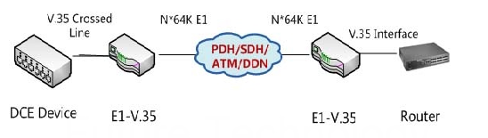
Application 1

Application 1

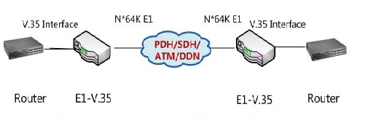

Solution Description: The E1 interface to V.35 interface to achieve the conversion, to take advantage of the operator's E1 copper cable resources, to solve the client branch through the V.35 interface router and the headquarters of the Internet networking needs.

Protocol Converter Series

3/3
V.35 Interface | Connector | DB25 Pin Female
V.35 Interface | Interface rate | In E1 framing mode, the V.35 interface rate is N*64Kbps (N = 1~ 31);  E1 transparent mode, V.35 interface rate of 2048Kbps;
V.35 Interface | Operate Mode | DCE
E1 Interface | Transmission mode | Provide transparent and framed E1 two working modes;  Transparent way, bandwidth 2048Kbps;  Framing method, the bandwidth can be set N × 64Kbps (N = 1 ~ 31);
E1 Interface | Number of interfaces | Provide single E1
Features | Network management capabilities | Support central office network management
Features | Clock Mode | Three clock modes are provided: master clock (internal clock), slave clock (E1 receive recovery clock), V.35 terminal clock (V.35 line clock)
Features | CRC check | Support CRC4 calibration adaptive
Features | Time slots follow | When framing mode is used in pairs, the time slot configuration of the local device can automatically follow the settings of the remote device
Features | Port loopback | Provides local and remote loopback testing
Features | Failover | Provide the failover function, which can notify the V.35 interface of the line side fault and judge the E1 line fault from the router;
Features | Phase adjustment | Support V.35 receive data phase automatic adjustment function
Power | Power supply | AC180~240V DC-36V~-72V DC 0V~36V
Power | Power consumption | ＜5W
Physical Dimension | Internal power supply | 216mm*140mm*31mm
Working environment | Working temperature | 0°C ~ 45°C
Working environment | Working Humidity | 5%~90% (non condensing)
Working environment | Storage temperature | -25°C ~ 70°C
Working environment | Storage Humidity | 5%~90% (non condensing)
TECHNICAL SPECIFICATIONS

Application 2

