
8E1 PDH Multiplexer
PDH Multiplexer Series

1/3
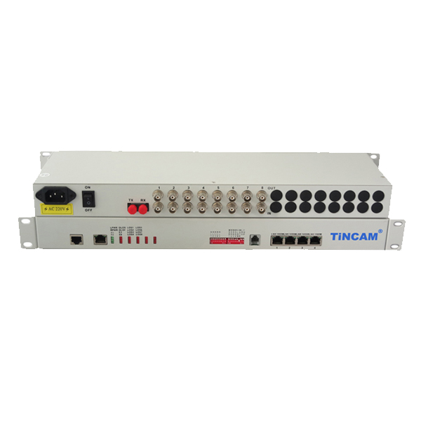
Product Description
The TBC-6240U series 8E1 PDH Multiplexer products are designed to transmit multiple E1 services over long distances using optical fibers. The 8E1 PDH optical transceivers utilize industry-leading technologies and proprietary VLSI integrated circuits and optical transmission products developed with dedicated digital multiplexers. This type of device supports point-to-point networking and is easy to install and maintain. With the chassis, the central office and the remote can be unified to achieve fault location quickly. As a result, the fault response speed is saved and the operation and maintenance costs are saved.
The 8E1 PDH Multiplexer uses large-scale programmable logic devices as the core part, using the latest design technology and large scale programmable integrated circuits for PDH optical transmission system to provide 16M transmission capacity.
- The circuit part of the equipment is all-digital circuit, the whole machine is reliable, stable, low power consumption, high integration, small size, easy to install and maintain.
- Equipment to meet the needs of telecom operators and private network users, in line with telecommunications standards. Suitable for power, postal services, banking and China Unicom, mobile telecommunications and other users needs, in line with the standards used by telecom operators;
- Abundant bit expenses Offer the transmission of main channel business of E1/G.703 interface and a high-speed data passway, offer RS232 low-rate data passway, official contact passway, network management passway at the same time.
- A variety of models to choose from, to meet different needs. Suitable for point-to-point optical transmission link for the public network and private network to provide high-quality, flexible and reliable digital optical transmission circuit.
- The optical transceiver has the advantages of high integration, strong reliability, low power consumption, small size and complete functions. It can also work stably under harsh environment. Machine installation without any adjustable point, easy to use, easy to maintain;
- The internal hardware and software are modular structure. Hardware part uses a large-scale FPGA, set encoding, decoding, information insertion, alarm switching in one, the circuit becomes simple, thereby enhancing the reliability of the machine, especially for high reliability requirements of the occasion.
PDH Multiplexer Series

2/3
Such as: mobile, China Unicom, telecommunications, electricity, public security, military, highway, aviation and other specialized communications networks; high degree of integration of hardware circuits, the whole power consumption is less than 10W; provide 8 E1 ports, E1 port uses digital clock recovery circuit and Digital smooth phase-locked circuit; Has a complete centralized monitoring function and sound and light alarm function; Circuit design ingenious and concise, equipment work is stable, the failure rate is extremely low. Supply voltage can be -48VDC / 24VDC / 220VAC arbitrarily choose one; optional multi-mode, single-mode dual-fiber, single-mode single fiber.
Product Features
- Provide 8 E1 interface;
- Provide 10/100BaseT interface;
- Ethernet interface speed 10M/100M adaptive, support VLAN protocol;
- Provide command E1 loopback function, optical path local loop function;
- All-digital clock recovery and smooth phase lock technology, high reliability and compatibility;
- Complete power supply, link and alarm indication function, the local device can monitor the current status of the remote device in real time;
- Provide 1-Channel business telephone interface, do not take up the E1 channel,can easily contact with the opposite end;
- Dual fiber bidirectional and single fiber bidirectional models are optional;
- Optical interface optional SC, FC;
- Conforms to carrier-class operation requirements, mean time between failures (MTBF) more than 100,000 hours;
- High reliability, providing 19 "rack mount,desktop,wall,at the same time with AC and DC power supply;
- Power can choose to AC 220V, DC -48V, the whole power consumption <5W; Provide SNMP network management functions;
Application
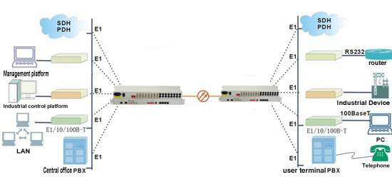

Product Parameter
PDH Multiplexer Series

3/3
Optical Interface Features | Fiber Type | Single Mode Fiber 8.3/125,8.7/125,9 / 125,10 / 125
Optical Interface Features | Fiber Wavelength | 1310nm/1550nm,Multi mode / single mode dual fiber,single mode single fiber (Optional)
Optical Interface Features | Fiber Interface | FC / SC / ST optional
Optical Interface Features | Optical code speed | 8E1 PDH is 21.120Mbit / s, 8E1+100M PDH is 155Mbit / s
Optical Interface Features | Optical code pattern | 8E1 PDH is 1B1H, 21.120Mbit / s, 8E1+100M PDH is 1B2B
Optical Interface Features | Optical source | LD
Optical Interface Features | Output optical power | ≥ -13dBm;
Optical Interface Features | Receiver type | PINFET
Optical Interface Features | Receiving sensitivity | ≤-38dBm (BER ≤ 10⁻¹¹)
E1 interface Features | Interface code | HDB3
E1 interface Features | Interface code speed | 2.048Mbit / s ± 50ppm
E1 interface Features | Interface Features | ITU-T G.703
E1 interface Features | Interface Type | BNC, RJ45
E1 interface Features | Interface impedance | 75Ω unbalanced / 120Ω balanced
Transmission distance | Multi mode | 0~2km
Transmission distance | Single mode | 20KM,40KM,60KM,80KM,100KM,110KM
Ethernet interface features | Interface Rate | 10/100M adaptive
Ethernet interface features | Interface Protocol | IEEE802.3,IEEE802.3U,IEEE802.1d,IEEE802.1Q
Ethernet interface features | Physical interface | RJ45
RS232 Interface | Operation mode | ≤19.2Kbit/s Asynchronous serial
RS232 Interface | Interface Type | RJ45
Power | Power supply | AC180~240V DC-36V~DC-72V DC+20V~DC+36V
Power | Power consumption | ＜6W
Working environment | Working temperature | 0°C ~ 50°C
Working environment | Humidity | 5%~95% (non condensing)
Working environment | Storage temperature | -40°C ~ 70°C
Dimension | 482.6mm*160mm*44mm（Rack-mount）

