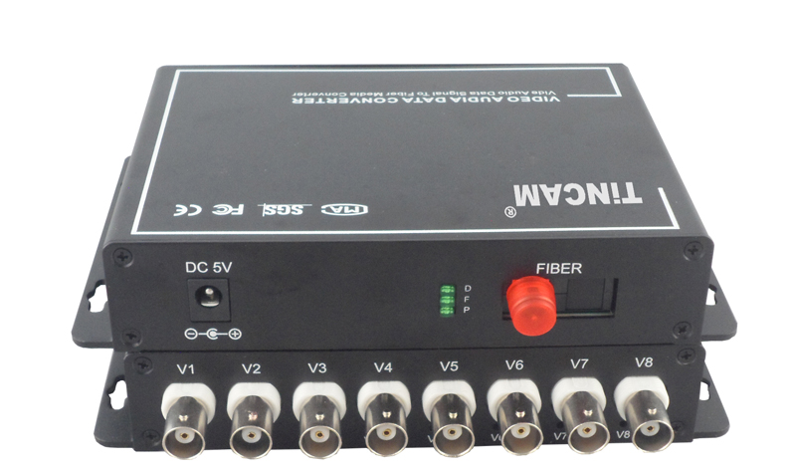

8-Channel Video Optical Transceiver
Video Optical Transceiver Series

1/3

Product Overview
The TBC-SF8V-S20T/R series digital video optical transceiver has a full-featured all-digital video optical transmission equipment that can transmit 8-Channel high-quality (10Bit) uncompressed video information and 1-Channel control signal on one fiber at the same time, optional audio、 data、 switch volume、 telephone . Meet bi-directional video, BIDI audio and data, can add functions: audio, data, digital volume, telephone. It uses all digital video compression transmission technology, high-quality video effects to meet the needs of users, plug and play design makes installation easy, without the need for on-site regulation, the optical modules and core circuits are imported components, High stability, all the optical and electrical interfaces are in line with international standards for different work environments. Optional audio, data, switch, Ethernet signal, E1 and telephone.
This product is based on multi-channel video optical transceiver, through the miniaturization and optimization of the design of the technology crystallization. Products with excellent price / performance, can completely replace the traditional small-capacity PFM analog optical products, and more stable performance, superior technical indicators. On-site support plug and play, does not require any optical adjustments; field wiring convenience; with power, optical and data loop instructions; optional two structural forms :stand-alone desktop installation and modular rack-intensive installation . This series digital optical transceiver products are mainly used for long-distance optical fiber transmission monitoring system, such as security monitoring, highway, electronic police, automation, intelligent community, customs, electricity, water conservancy, petroleum, chemical and many other fields.

Optical Characteristics：
fiber type/  parameter | Fiber interface type | Emission wavelength nm | Transmit power dBm | Receiver sensitivity dBm | Optical  saturation dBm | Optical loss dBm/km | Transmission distance km
Multi Mode | SC/FC | 850 | -18.5~-14 | -35 | -8 | 2 | 0~2
Multi Mode | SC/FC | 1310 | -19.5~-16 | -36 | -9 | 1 | 0~3
Single Mode | SC/FC | 1310 | -15~-10 | -34 | -8 | 0.5 | 0~20
Single Mode | SC/FC | 1310 | -12~-5 | -36 | -3 | 0.5 | 0~40
Single Mode | SC/FC | 1550 | -5~0 | -38 | 2 | 0.25 | 0~60
Video Optical Transceiver Series
2/3

Product Features：
- 10-bit digital encoding and uncompressed video transmission;5Hz-10MHz video channel; automatically compatible with PAL, NTSC, SECAM video system ;
- With APC circuit, the output optical power is constant, the dynamic range is large;
- Without downtime maintenance in the process of using, with hot-swappable;
- The video quality is independent of the transmission distance within the allowable range of optical power;
- Support video, data, audio transmitted in parallel ,bidirectional / unidirectional optional;
- Gigabit fiber transmission, large capacity, easy to upgrade;
- Power and other parameters status indicator LED can monitor the operation status of the system;
- Support any high resolution video signal; support video lossless regenerative relay;
- Support RS232/RS485/RS422 or Manchester code;
- Advanced adaptive technology, does not require on-site electrical or optical adjustment;
- Industrial modular design makes the device reliable and flexible; Can automatically restore the overload protection; unique full built-in power supply design;Desktop, wall mounted, 19 inch 1U rack or 4U card insert; support for user customization.

Parameter
Optical characteristics:
Optical interface: SC/FC/ST
Wavelength: single mode 1310nm/1550nm ；multimode 850nm/1310nm
Fiber; multimode, single mode;
Transmission power : -9dBm/-5dBm
Transmission Distance: 0-100km;
Receiving sensitivity: better than -36dBm
Features: Can be customized according to user needs for different interface types.
Video characteristics:
Channel：8-Channel video
Video interface form: BNC
Signal system: PAL/NTSC/SECAM; Nominal input/output level: 1Vp-p
Video input/output impedance: 75Ω（unbalanced)
Video input/output voltage: 1Vp-p
Video bandwidth: 8MHz
Video sampling: 15MHz high speed sampling
Differential gain:(10% -90% APL) DG<1% (typical)
Differential phase:(10% -90% APL) DP<0.7o (typical)
Video Optical Transceiver Series Series

3/3
Video signal to noise ratio(weighted):S/N ≥ 70dB (maximum optical link loss)
Color brightness delay difference : 10ns (typical)
Color brightness gain difference: ± 10% (typical);
Note: support forward, reverse, BIDI video.

Ambient temperature: -30 ℃ ~ 75 ℃;
Storage temperature: -40 ℃ ~ 85 ℃
Relative humidity: 0 ~ 95% (non-Condensing);
Size: Standalone (225mm*200mm*40mm)
Size: Card (standard 4U centralized management rack)
Rated supply voltage: AC220V / 50Hz;
Internal power consumption: 2.5 W;
MTBF: ≥10⁵ hours

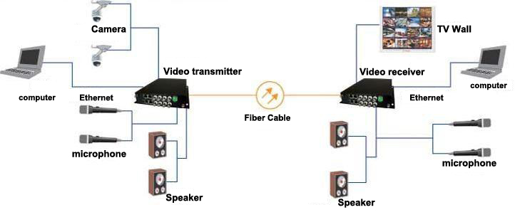
Application
Application environment:
security system, TV medical, high-fidelity video and video conference call, real-time monitoring and control system, intelligent traffic monitoring system (ITS), remote multimedia teaching / campus monitoring, long-distance radio and television transmission system

