
Fiber Switch Series
1/2
10/100M 1 fiber port +8 RJ45 ports Switch

Product Description

The TBC-3418E-S20 Series 10/100Mbps 1 fiber port + 8 RJ45 ports Switch converts 8 independent 10/100Base-TX twisted pair electrical signals and 1 single 100Base-FX optical signal to each other. It extends the network's reach from the 100M limit of copper to 120KM. By using switching and store-and-forward technology to enable data before the two network connections to the media, it greatly increases the fabric flexibility of Fiber Ethernet and Reduces the cost of the network set up to support dual-fiber multi-mode, dual-fiber single-mode, single-mode single-mode fiber and other optical transmission.
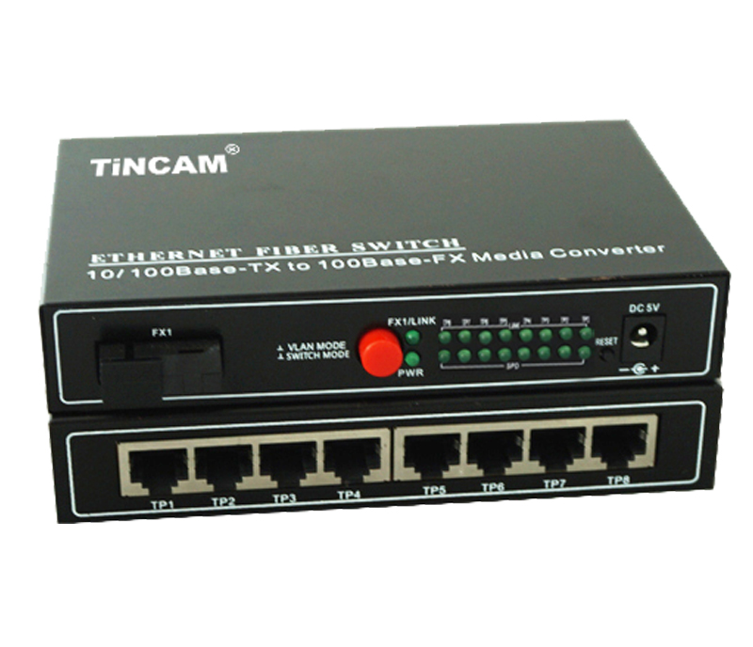

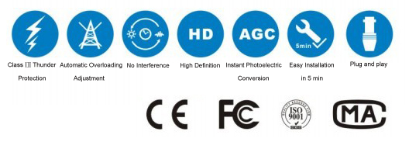

Product Features

- Storage and forwarding capabilities to support rate adaptation and protocol translation;
- Adaptive connection 10M and 100M network and the network port supports full-duplex/ half-duplex adaptation and traffic control;
- Automatic detection and correction of incorrect poles on each port of a twisted pair;
- Data transfer rate (line speed) is 14,880 frames per second (10M);
- Data transfer rate (line speed) is 14,8800 frames per second (100M);
- The amount of power ≤ 5W;
- Support 12K effective MAC address table; MAC supports MAC address learning and aging automatically;
- 8 MB packet buffer;
- With broadcast storm protection;
- Flexible access mode;
- High degree of system reliability and stability;
- Comply with 10Base -T、100Base-T、100Base-FX and IEEE802.3u standard;
- Multimode transmission distance up to 2 km, single mode transmission distance up to 120 km;
- All components using well-known foreign companies, circuit layout science, anti-interference ability;
- Dynamic LED lights, working status at a glance;
- Support MDI / MDI-X port automatically flip;
- Support 1 optical port and 8 RJ45 ports;
- Built-in professional switching power supply, safe and stable, the whole power consumption is less than 10W;
- Support physical isolation ;
- Support VLAN function (optional);
- Built-in high-capacity independent transceiver FIFO buffer, support for FIFO, to prevent data loss;

Fiber Switch Series
2/2
Product Specification

Access method | 10/100Mbps
Standard | IEEE 802.3 10BASE-T , IEEE 802.3u 100BASE-TX and 100Base-FX
Wavelength | 850nm/1310nm/1490nm/1550nm
Data transfer rate | Ethernet:10Mbps (Half-duplex),20Mbps(Full-duplex)  Fast Ethernet:100Mbps (Half-duplex),200Mbps(Full-duplex)
Port | 1 optical port and 8 RJ45 ports
Power Input | DC 5V / 2A
Operating temperature | -10 ~ 60 ℃
Storage Temperature | -40 ~ 70 ℃
Operating humidity | 5%~90% non-condensing
Product Size | 222mm * 132mm * 36mm
weight | 0.69kg



